2019 Homecoming Mums, Garters, and Spirit Supplies
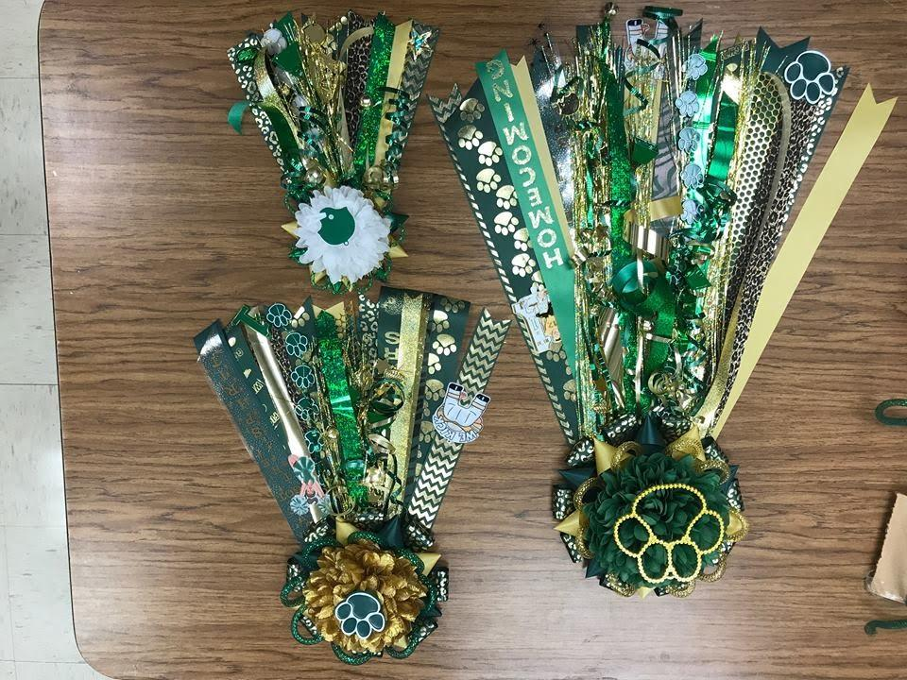
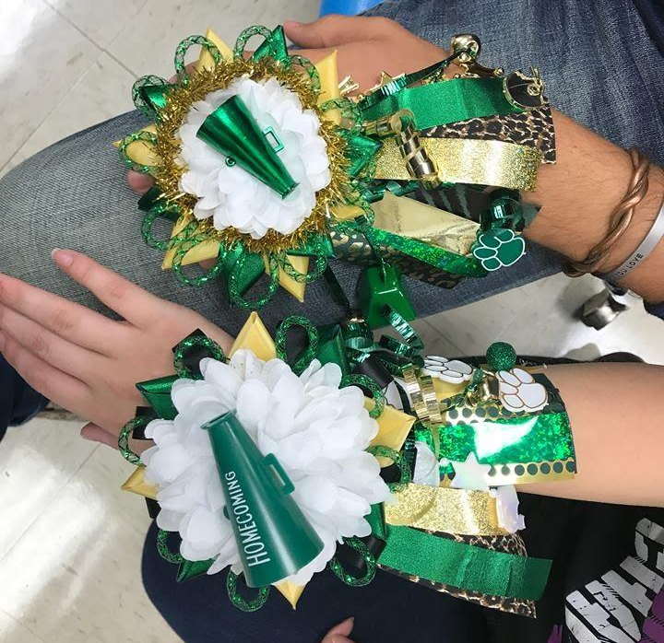
Homecoming will be on THURSDAY October 3rd, so we must have orders in by FRIDAY September 27th!! All items will be delivered to classrooms and lockers on Wednesday afternoon. Examples can be seen in the FCS classroom. Fill out the order form on the reverse side and return it to the FCS department. Please email cdaniel@guthriecsd.net if you have any questions or concerns. Thank You for your support!! Go Jags!
Tiny
8” ribbons with 2 charms and 3 bells
$10
Finger
4” Ribbons with 2 charms and 3 bells
$7
Wrist
5” Ribbons with 2 charms and 3 bells
$8

Large
18” ribbons with 4 charms and 5 bells
$20
Small
12” ribbons with 3 charms and 4 bells
$15
Deluxe
36” ribbons with 7 charms and 7 bells
$35(Not Shown)

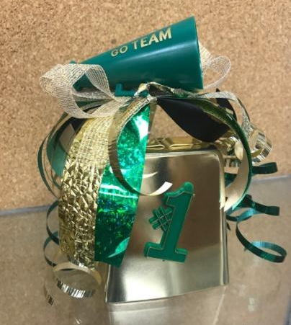
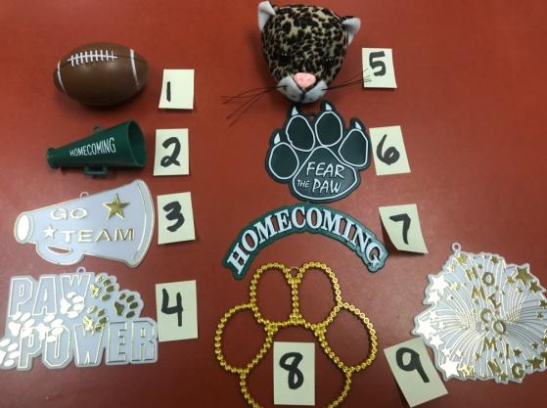
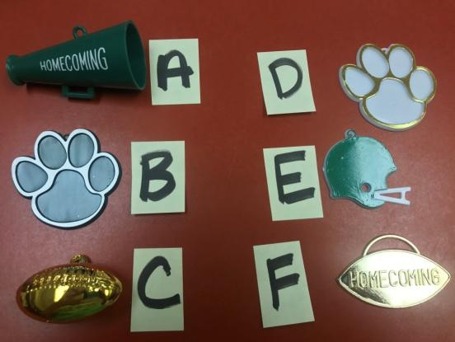
Lg. Cowbell
4” Gold Cowbell with Various Decorations
$8

Center Pieces
For Small, Large, & Deluxe Options
Center Pieces
For Finger, Wrist, and Tiny Options
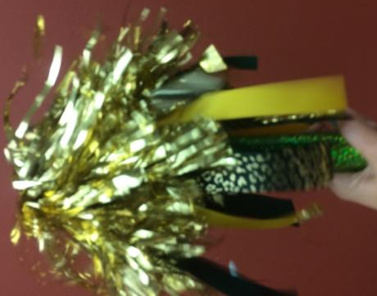
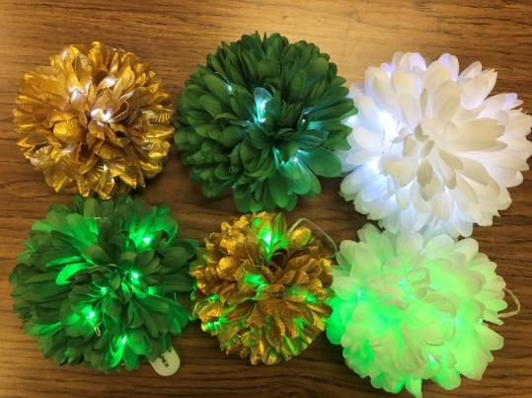
Spirit Stick
10” handle with 2 poms, 3 charms, and 5 bells
$7
Cheer Bow $5
8” Bow (Choose White w/ Paws or Green w/ Jag print)
Lights
Battery Operated
Green or White
Add $5
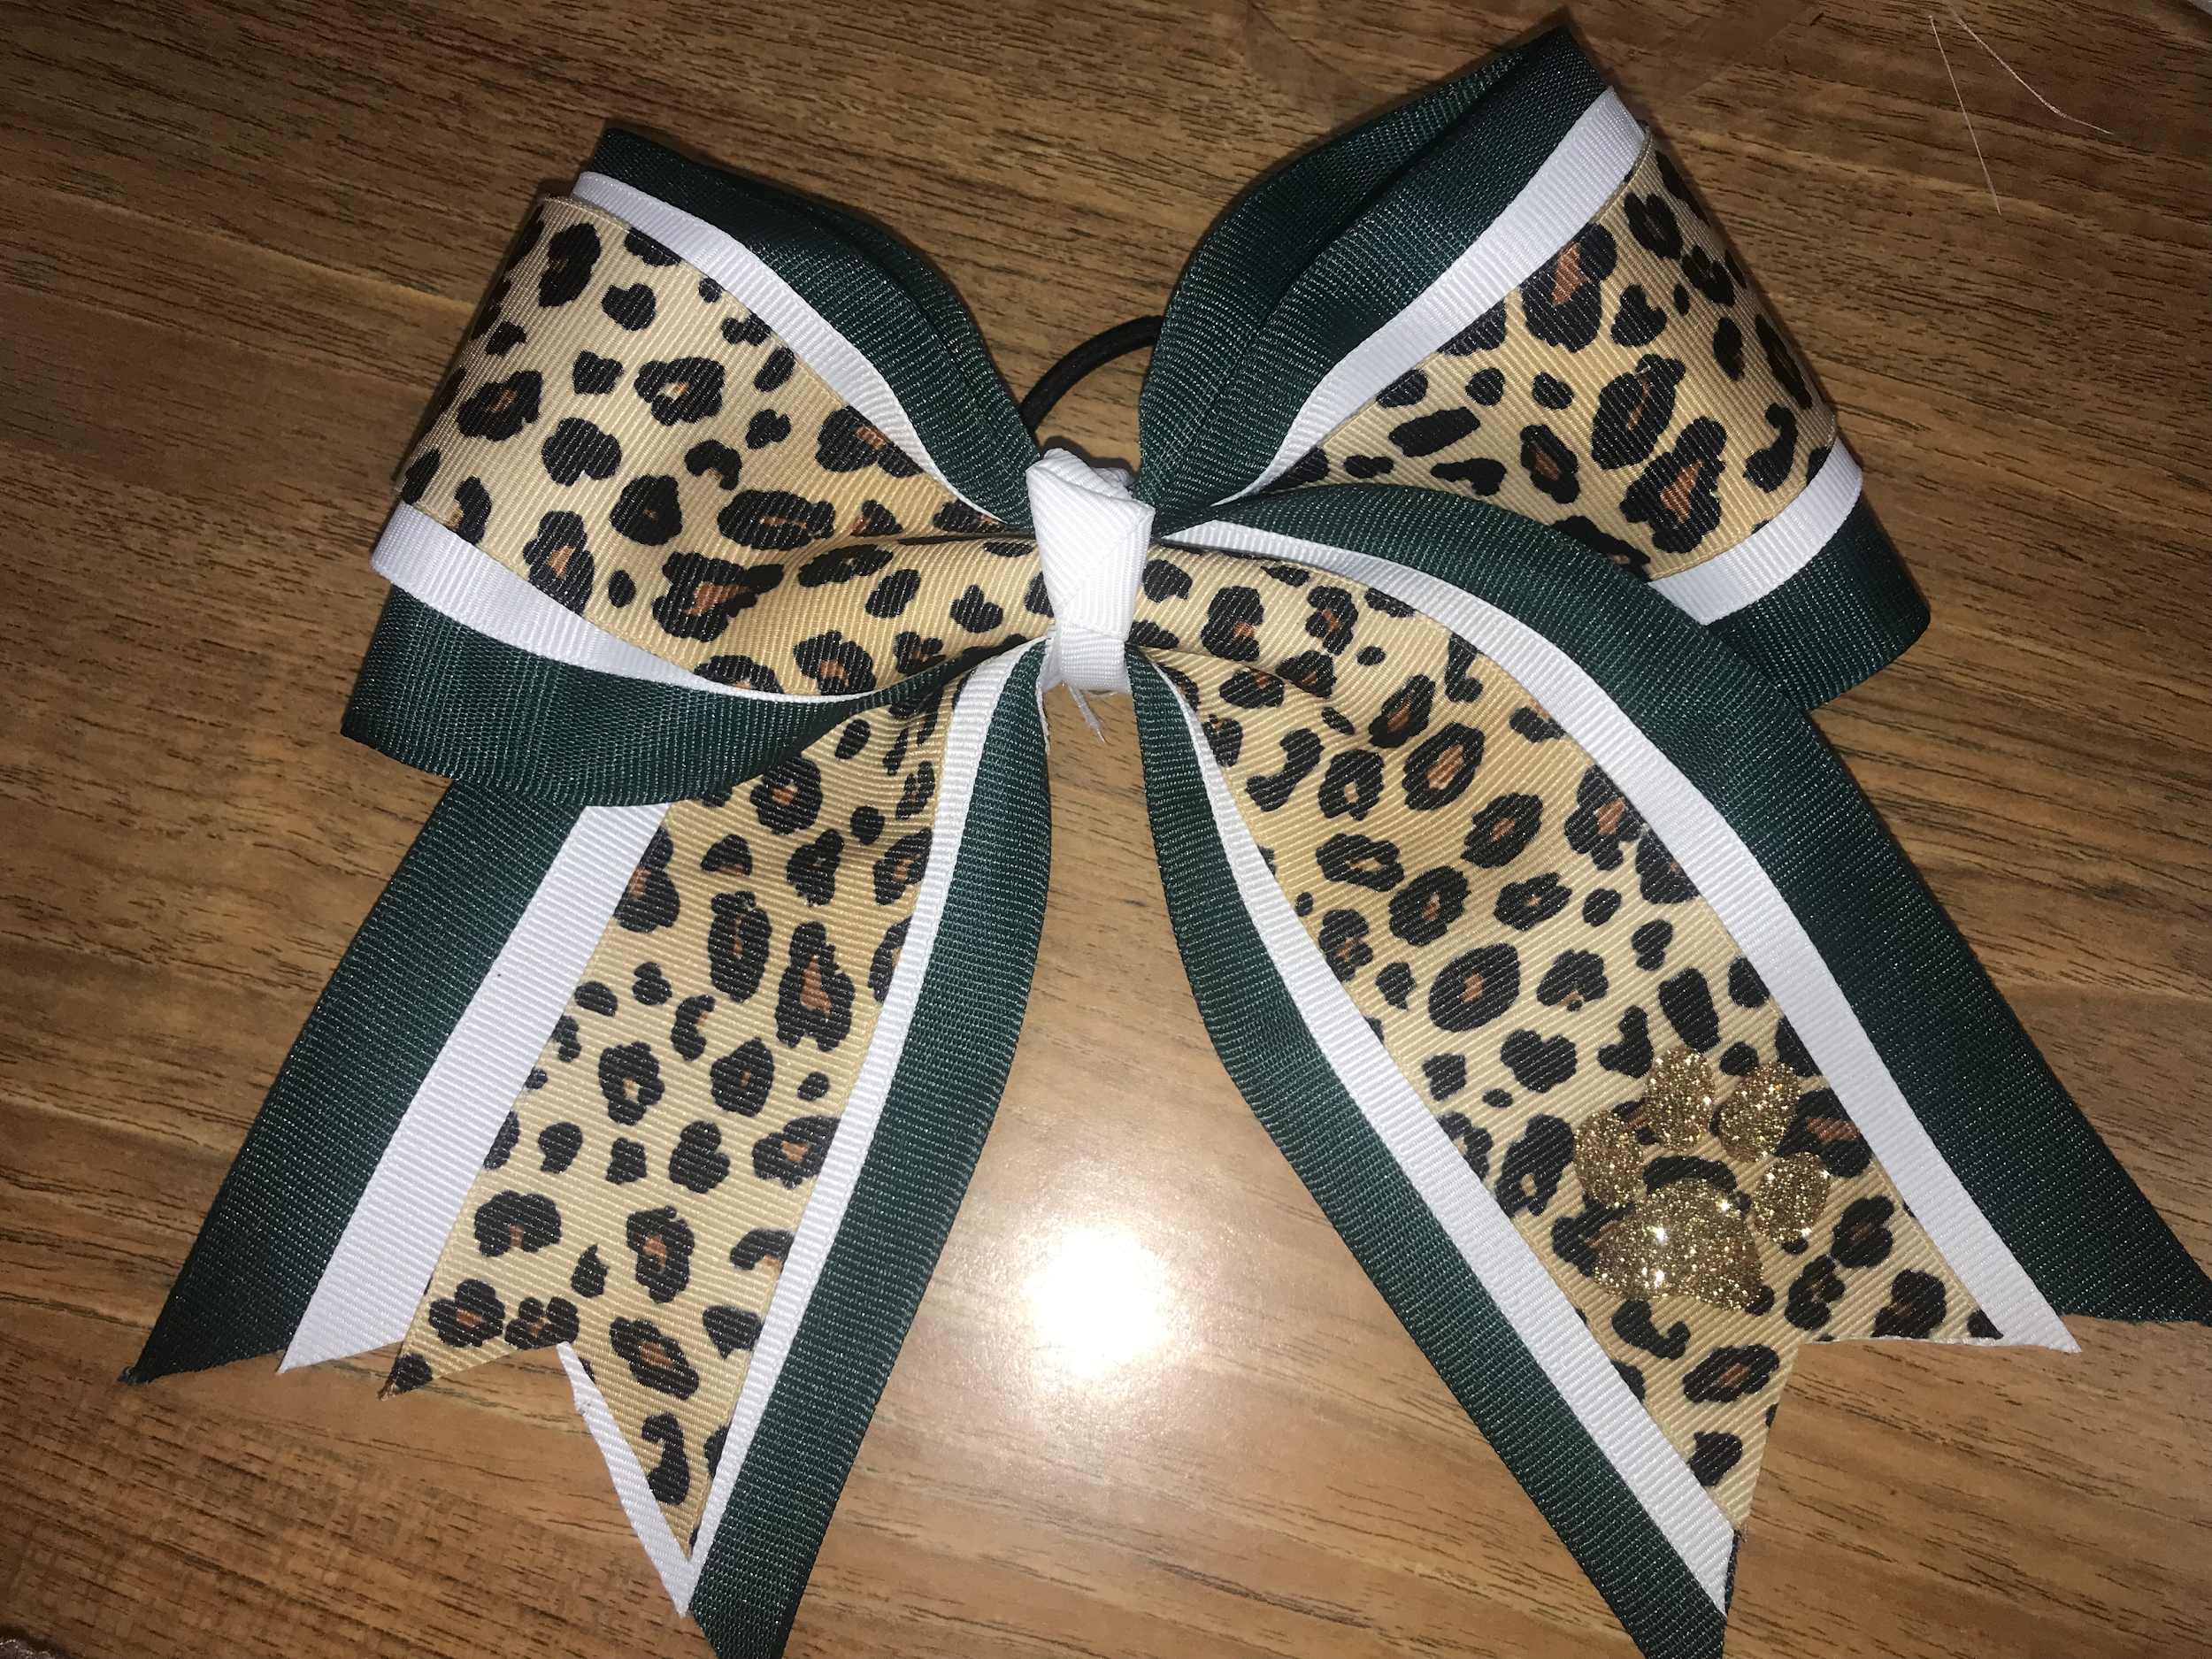
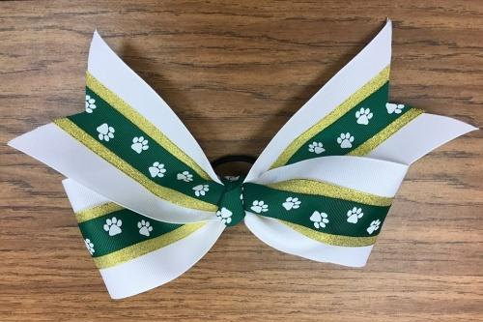
Name__________________________________ Grade____________
SOME SUPPLIES ARE LIMITED!! EVERYTHING WILL BE ON A FIRST COME, FIRST SERVED BASIS, SO GET YOUR ORDERS IN EARLY. YOU WILL BE CONTACTED IF WE RUN OUT OF SOMETHING YOU REQUEST.
Select Size | Circle One | Circle Flower and Lights Options  (See Reverse Side) | Circle Number of Flowers  (See Pic Below) | Circle Center Piece  (See Reverse Side)  (Optional) | Name &  Number (Optional) | Class Charm  (Optional)
Finger Mum  $7 | N/A | White Flower or No Flower  **This could also be  pinned on a ponytail** | N/A | A B C  D E F  None |  | N/A
Wrist Mum  $8 | N/A | White Flower or No Flower  **This could also be  pinned on a ponytail** | N/A | A B C  D E F  None |  | N/A
Tiny  $10 | Mum with Pin  Garter on Arm  Garter on Leg | White Green No Flower  Metallic Gold (Add $2)  Green or White Lights in Flower(Add $5) | N/A | A B C  D E F  None |  | Fresh Soph  Jr Sr  None
Small  $15 | Mum with Pin  Garter on Arm  Garter on Leg | White Green No Flower  Metallic Gold (Add $3)  Green or White Lights in Flower(Add $5) | 1 Flower  2 Flowers (Stacked) Add $2  3 Flowers (Heart or Stacked) Add$4 | 1 2 3  4 5 6  7 8 9  None |  | Fresh Soph  Jr Sr  None
Large  $20 | Mum with Pin  Garter on Arm  Garter on Leg | White Green No Flower  Metallic Gold (Add $3)  Green or White Lights in Flower(Add $5) | 1 Flower  2 Flowers (Stacked) Add $3  3 Flowers (Heart or Stacked) Add$5 | 1 2 3  4 5 6  7 8 9  None |  | Fresh Soph  Jr Sr  None
Deluxe  $35 | Mum with Pin Only | White Green  Metallic Gold (Add $3)  Green or White Lights in Flower(Add $5) | 1 Flower  2 Flowers (Stacked) Add $3  3 Flowers (Heart or Stacked) Add$5 | 1 2 3  4 5 6  7 8 9  None |  | Fresh Soph  Jr Sr  None
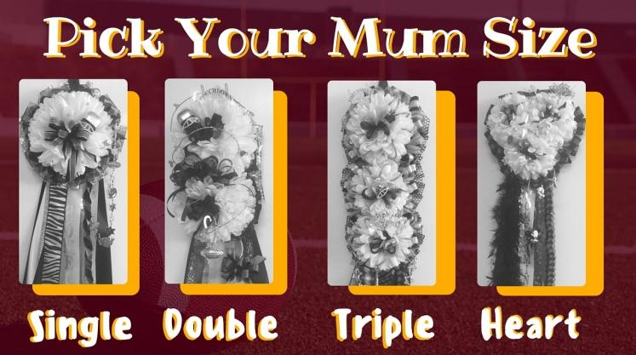
Other Spirit Supplies
**Please put Quantity on the Blank
____Spirit Stick $7 (Name/Number optional)
____Cheer Bow (White w/Paws) $5
____Cheer Bow (Green w/Jag Print) $5
____Large Cow Bell $8 (Name/Number optional) Total:_$______________

