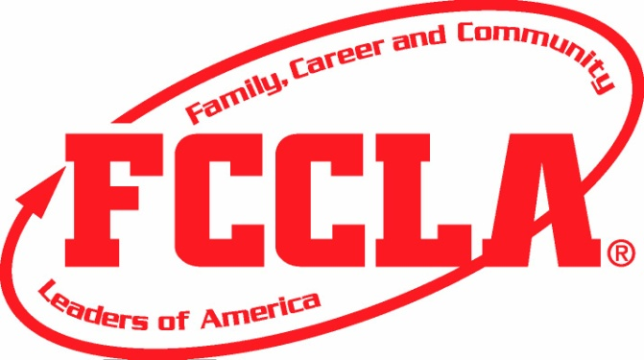
Are you ready for some
FOOTBALL
and
PIZZA????

We will be selling “Take and Bake” style pizzas just in time for the Super Bowl! They will be 16” pizzas loaded with your favorite toppings ready to bake for the game or freeze for later. Pizzas can be picked up at the FCS classroom or sent home with your student on Friday February 2th. Please return the order form on the back no later than Friday January 26th.
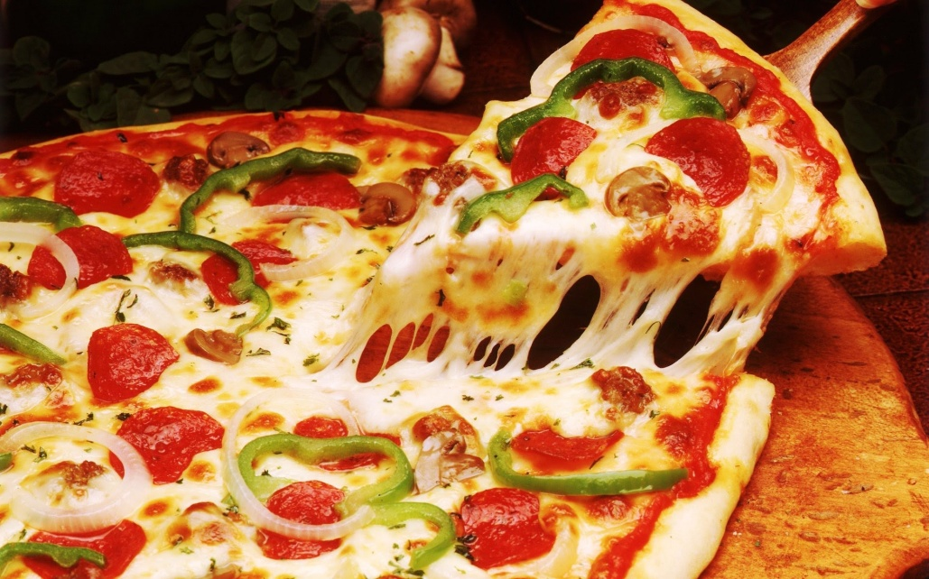

Pizza Type | Description | Quantity | Do you want any ingredients omitted? | Total
Cheese  $8.00 | Plain Cheese Pizza with Tomato Sauce |  | N/A
Pepperoni  $9.00 | Cheese Pizza with Pepperoni |  | N/A
Meat Lover’s  $10.00 | Cheese Pizza with Pepperoni, Sausage, and Bacon
Supreme  $10.00 | Meat Lover’s Pizza with Onion, Bell Pepper, Mushrooms, and Olives
Grand Total
Don’t forget to stock your freezer with pizzas for those busy nights!
Name:_______________________________
Phone Number:________________________
___I will pick up my pizza(s) in the FCS room between 3:00-4:00 pm.
___I want my pizza(s) sent home with _______________.
**Pizzas must be paid for before Delivery (Feb 2)**
**Please make checks to Guthrie FCCLA**

