2017 Homecoming Mums, Garters, and Spirit Supplies
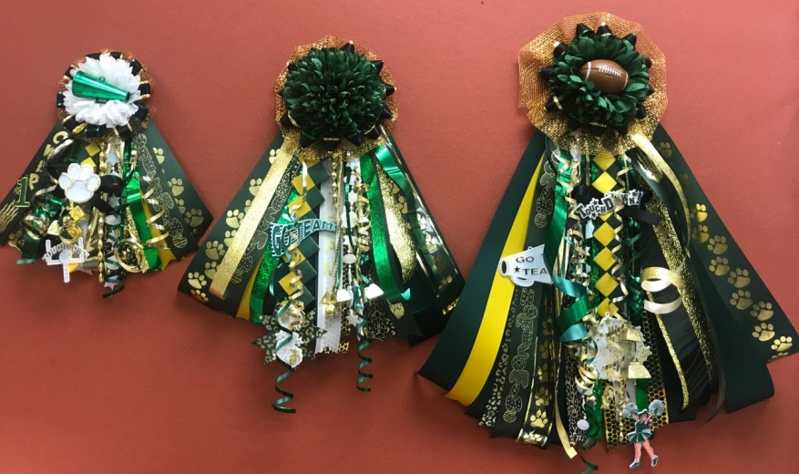
Homecoming will be on THURSDAY October 5th, so we must have orders in by Tuesday October 3rd!! All items will be delivered to classrooms and lockers on Wednesday afternoon. Displays can be seen by the FCS classroom. Fill out the order form on the reverse side and return it to the FCS department. Please email cdaniel@guthriecsd.net if you have any questions or concerns. Thank You for your support!! Go Jags!
Small
12” ribbons with 3 charms, and 4 bells
$15
Medium
18” ribbons with 4 charms, and 5 bells
$20
Tiny
8” ribbons with 2 charms, and 3 bells
$10
Lg.

Large(Not Shown)
24” ribbons with 5 charms, and 6 bells
$25
Deluxe (Not Shown)
36” ribbons with 7 charms, and 7 bells
$35

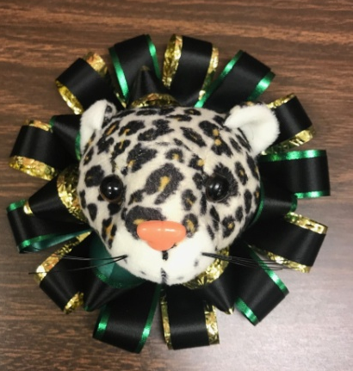
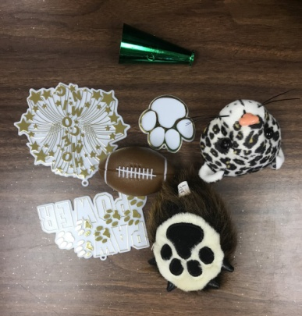

Center Pieces
Reversible Headband with Removable Flower $7
Example of Mum/Garter top without flower
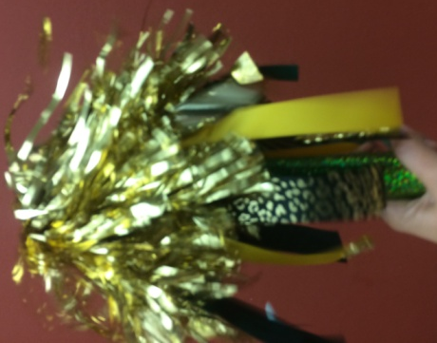
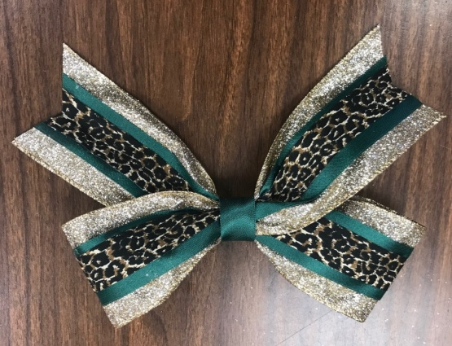
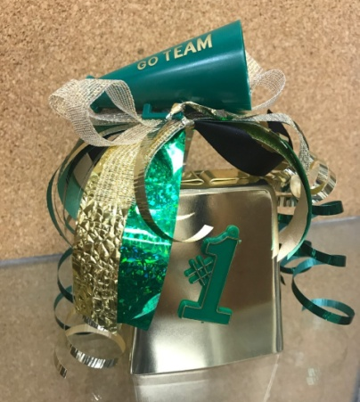

Spirit Stick
10” handle with 2 poms, 3 charms, and 5 bells
$7
Lg. Cowbell
4” Gold Cowbell with Various Decorations
$8
Cheer Bow
8” Bow with Green, Gold, and Jaguar Print Ribbon
$5

Name__________________________________ Grade____________
Mums and Garters
**Please put Quantity on blank and circle Mum/Garter option
____Tiny (Mum or Garter) $10
____Small (Mum or Garter) $15
____Medium (Mum or Garter) $20
____Large (Mum or Garter) $25
____Deluxe (Mum Only) $35
Flower Option
**Please circle one option for each mum or garter ordered
White Flower
Green Flower
No Flower (Ribbon Only-see example)
Paw Print (White Flowers with green boa) **Add $7**
Paw Print Flowers will resemble this, but will be smaller with green boa.
**This can only be added to the Medium, Large, and Deluxe**

Center Piece (Optional)
**Please Circle One
Megaphone Football Paw Print Plush Jag Head Plush Paw

Paw Power Homecoming Burst None

Name and Number on Streamer (Optional)
Orders due TUESDAY OCTOBER 3rd
Name_________________ Number________
Name_________________ Number________

Class Charm (Optional)
** Circle One for High school Students
Freshman Sophomore Junior Senior

Other Spirit Supplies
**Please put Quantity on the Blank
____Spirit Stick $7 (Name/Number optional)
____Head Band $7 (Limited Quantities)
____Cheer Bow $5
____Large Cow Bell $8 (Name/Number optional) Total:_$______________

