Guthrie
Mini Cheer Camp
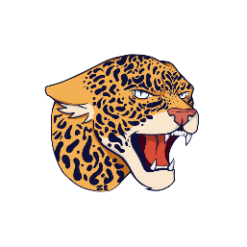
Come Cheer with Us!!
Monday, August 8, 2022
Guthrie Gym
3:00-6:00 PM
Cheer Camp Participants will receive a t-shirt and cheer with the GHS Squad during halftime of the Homecoming Football Game.

Please pre-register for a cheer t-shirt at the school office or register online

https://docs.google.com/forms/d/e/1FAIpQLSfdSAI2t9fqWJY-dSllAlT4hSTlQfWPExjUu_crEPlRd5s40g/viewform?usp=pp_url

